ini Project - 1

Student Name/ID Number: | Viddy Virstandi Paramanayaka Andanawari Purnama
Unit Number and Title: | ACWD Module 4 – Database Design & Implementation
Academic Year: | 2022
Unit Assessor: | Arvinder Kaur
Project Title: | Database Design for Community Portal
Issue Date: | 26 July 2022
Submission Date: | 26 July 2022
Internal Verifier Name:
Date: | 26 July 2022

Learner declaration
I certify that the work submitted for this assignment is my own and research sources are fully acknowledged.

Student signature: Date: 26 July 2022

Purpose of this project
Purpose of this project
To demonstrate your capabilities in the following areas:
• Design a Database for Community Portal
Submission Format
- Description of Entities in the database
- Screen capture of the ER Diagram
- Screen capture of Data
- Screen capture of Normalized Database Design
- Documentation of Relationships
Project Brief & Guidance
Scenario:

Refer to the Project Scenario for the Module Project
You have been approached by ‘ABC Jobs Pte Ltd’ as a website developer to develop a community portal for Software Developers. The project will be carried over through Module 3, Module 4, Module 5 and Capstone project. For this module the scope is to Design, Develop, Implement & Document Apache Struts Framework Website.
The Scope of the Project is to design a Community Portal Similar to Linkedin.com. Users will be able to register in the portal using the Registration Page. Users of the portal can search for other users using various parameters such as First Name, Last Name, Company Name, City & Country. Users will be able to view the Public Profile of users after searching them. The portal allow users to login, request for forgotten password and Update their profile information

The scope of the mini project is to design the database.

The overview of the project is as below
There are 2 types of users in this Community portal. They are
- Software Programmer
- Administrator

Software Programmer should be able to perform following functions in the portal

- Allow the programmers to register in the portal, show a thank you page & send a registration confirmation email.
- Search & Find Other Programmers after login and view their profile.
- Provide Login Page
- Provide password retrieval functionality.
- Update their Profile after logging in.

Following Functionality is part of Database Design & Will be enhanced as features as required in the Capstone Project, Depending on time availability.

- Send Messages to Each Other on the Portal
- Create Threads & Post Replies to a Thread
- Post Job Opportunities in the Portal

Administrator should be able to perform following functions in the portal
- Administer user data.
- Send bulk email inviting programmers to register on the community portal

The portal consist of the following Key pages (For Reference)
- Community Portal Home Page
- Registration Page
- Registration Confirmation Page
- Update Profile Page
- Search Users Page
- List Search Results
- Public Profile Page
- Registration Confirmation Email
- Login Page
- Forget Password Page
- Design the Forget Password Confirmation Page

Following Functionality is part of Database Design and will not be part of development & Will be enhanced as features are required in the Capstone Project, Depending on time availability.
- Send Messages
- Read Messages
- Post in Message Board
- List Message Board
- Read A Thread
- Post Job Opportunities
- List Job Opportunities & Responses

The scope of this assignment
The scope is to design the community portal database.
- Identify the Entities in the Community Portal Database
- Create ER Diagram for the Community Portal Database

- Create Sample data for all tables in the community portal (At least 3 tables)
- Normalize the complete database to 3rd normal form (Provide screen capture of the normalization done)
- Identify the relationships in tables & document them

- Identify the Entities in the Community Portal Database
Name | Desc | Col
User | Data users who have registered at ABC Jobs | user_id  first_name  last_name  company  city  country  email  password
User Profile | Data for user profiles at ABC Jobs | user_id  status_id  username  job_status  experience  company  bio
Admin | Admin data that manages the Abc Jobs website | admin_id  first_name  last_name  email  password
Job | Job vacancy data on ABC Jobs | job_id  company_name  job_desc  job_type
Thread | Data of users who have created threads on ABC Jobs | thread_id  date  time  thread_desc  comment
Messages | Data message user to send messages between users | message_id  date  time  message  to  from

- Create ER Diagram for the Community Portal Database
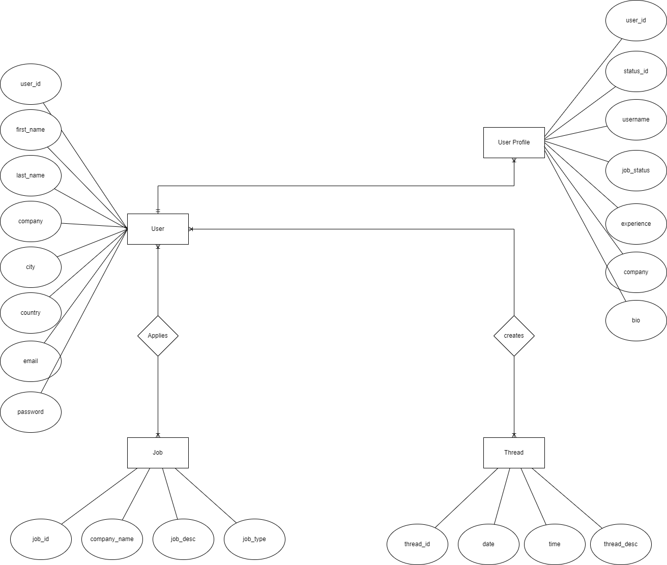

- Create Sample data for all tables in the community portal (At least 3 tables)

- User
user_id | first_name | last_name | company | city | country | email | password
user1 | Viddy | Purnama | Google | Reykjavík | Iceland | Ncull@email.com | password12345
user2 | Amir | El-Amari | Lithan | Jakarta | Indonesia | cypher@email.com | cypher12345
user3 | Pankratiyv | Antonov | Intel | New York | USA | antonov@email.com | antonov12345

- Job
job_id | company_name | job_desc | job_type
job1 | Google | We are looking for Full Stack Developer | Full-Time
job2 | Amazon | We are looking for Front-End Developer | Part-Time
job3 | Lithan | We are looking for mentor | Full-Time

- Thread
thread_id | time | date | thread_desc
thread1 | 10:35 PM | 10/2/2021 | I’m Very Happy
thread2 | 9:52 AM | 11/11/2021 | It's time to coffee
thread3 | 7:40 AM | 1/23/2022 | I'm working on Google
thread4 | 3:00 PM | 4/1/2022 | The best experience
thread5 | 7:00 AM | 4/23/2022 | I'm working on Amazon
thread6 | 8:30 AM | 4/19/2022 | I like this Company
thread7 | 6:12 AM | 5/11/2022 | I'm enjoying this

- Normalize the complete database to 3rd normal form (Provide screen capture of the normalization done)
user_id | first_name | last_name | job_id | company_name | thread_id | thread_desc
user1 | Viddy | Purnama | job1  job2 | Google  Amazon | thread3  thread1 | I'm working on Google  I’m Very Happy
user2 | Amir | El-Amari | job3 | Lithan | thread6  thread7 | I like this Company  I'm enjoying this
user3 | Pankratiyv | Antonov | job2  job3 | Intel  Amazon | thread2  thread5 | It’s time to coffee  I'm working on Amazon

What is NF1
To form a relation/table. In order to be in first normal form, it is necessary to remove the attributes that deserves double.
user_id | first_name | last_name | job_id | company_name | thread_id | thread_desc
user1 | Viddy | Purnama | job1 | Google | thread3 | I'm working on Google
user1 | Viddy | Purnama | job2 | Amazon | thread1 | I’m Very Happy
user2 | Amir | El-Amari | job3 | Lithan | thread6 | I like this Company
user2 | Amir | El-Amari | job3 | Lithan | thread7 | I'm enjoying this
user3 | Pankratiyv | Antonov | job2 | Intel | thread2 | It's time to coffee
user3 | Pankratiyv | Antonov | job3 | Amazon | thread5 | I'm working on Amazon

What is NF2
All non-key attributes are fully dependent on the primary key or contain no partial dependencies.

user_id | job_id | thread_id
user1 | job1 | thread3
user1 | job2 | thread1
user2 | job3 | thread6
user2 | job3 | thread7
user3 | job2 | thread2
user3 | job3 | thread5

What is NF3
Each non-key attribute has no transitive dependency on the primary key.

User
user_id | job_id
user1 | job1
user1 | job2
user2 | job3
user2 | job3
user3 | job2
user3 | job3

Jobs
job_id | company_name | thread_id
job1 | Google | thread3
job2 | Amazon | thread1
job3 | Lithan | thread6
job3 | Lithan | thread7
job2 | Intel | thread2
job3 | Amazon | thread5

Thread
thread_id | thread_desc
thread3 | I'm working on Google
thread1 | Very Happy
thread6 | I like this Company
thread7 | I'm enjoying this
thread2 | It's time to coffee
thread5 | I'm working on Amazon

- Identify the relationships in tables & document them
1. Admin to User relations is one to many.
2. User to User relations one to one

